FINAL PROJECT
7440 - INTERNET OF THINGS AND BIG DATA ANALYSIS
Name : Christine Dewi
Student ID : 10714904

A1. write a program to get the weather information from the website and response it on your line social network.
- Use open map weather website and register account
https://home.openweathermap.org/users/sign_in
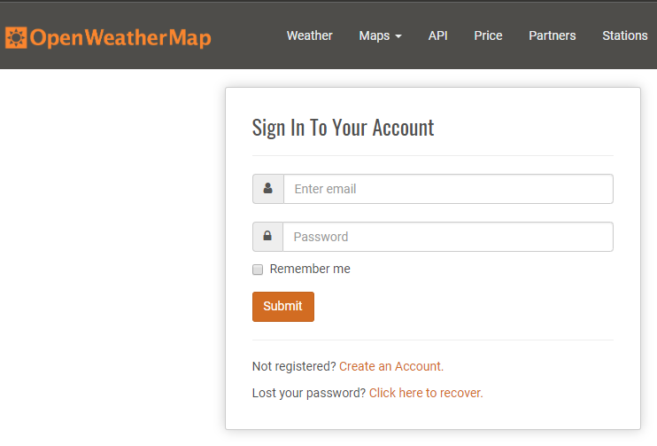
- After that you can get your API
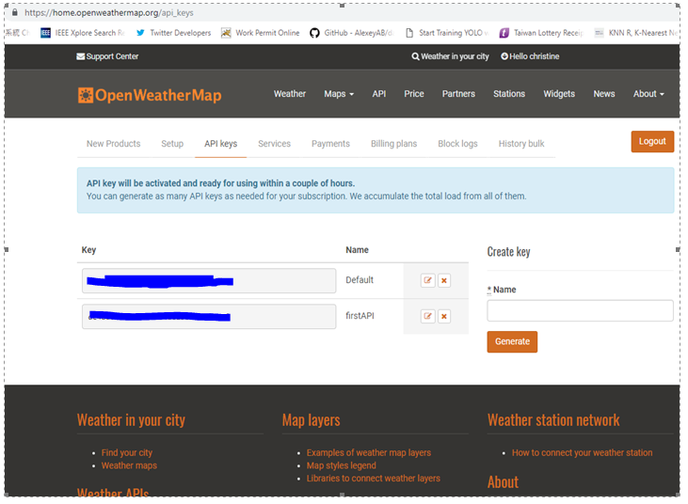
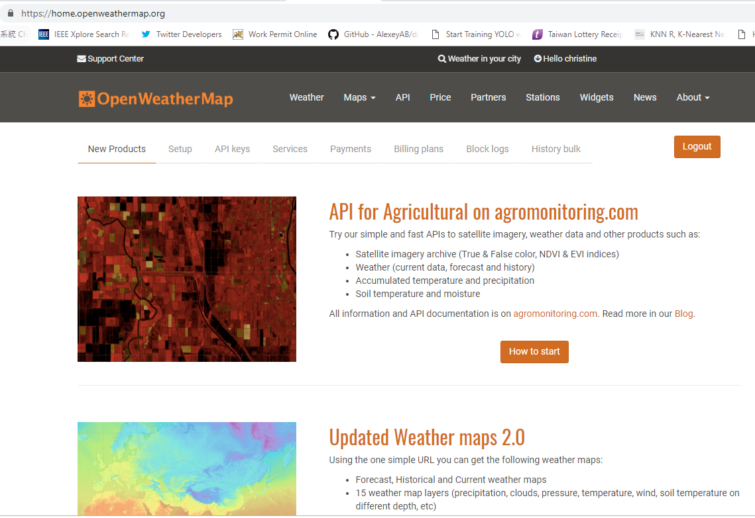
- Make account for twitter developer from website to get API
https://developer.twitter.com/en/apps

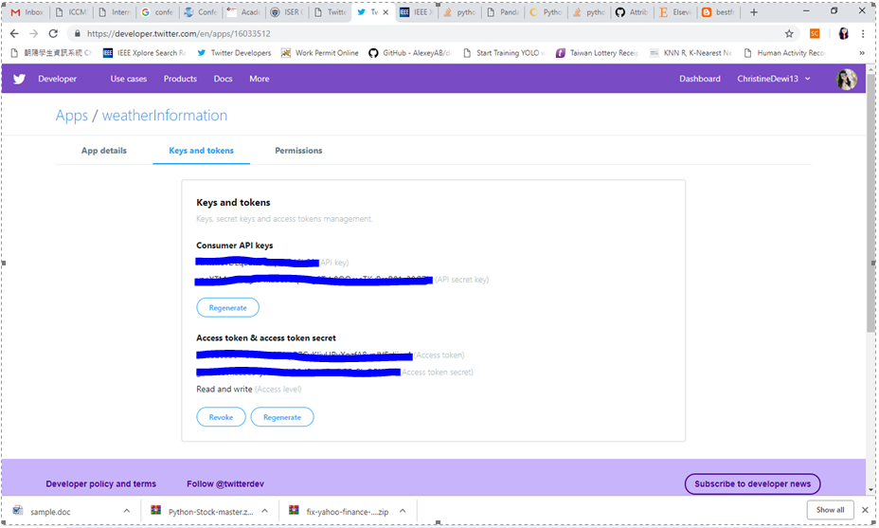
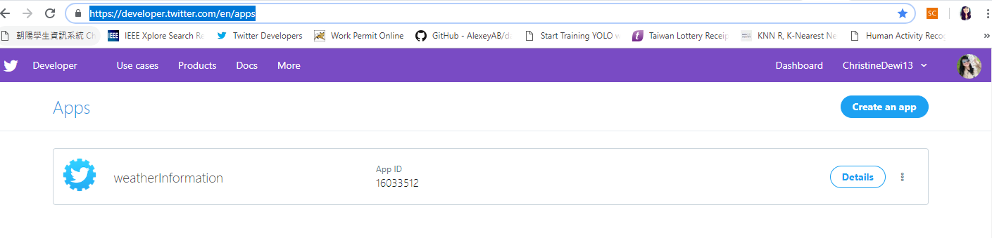
- Sourcode Phyton
# -*- coding: utf-8 -*-
"""
Created on Mon Dec 10 10:13:21 2018
@author: Christine
"""
import datetime
import json
import urllib.request
import tweepy

# Create variables for each key, secret, token
consumer_key = 'XXXXXXXXXXXXXXXX'
consumer_secret = 'XXXXXXXXXXXXXXX'
access_token = 'XXXXXXXXXXXX
access_token_secret = 'XXXXXXXXXXXX'

# Set up OAuth and integrate with API
auth = tweepy.OAuthHandler(consumer_key, consumer_secret)
auth.set_access_token(access_token, access_token_secret)
api = tweepy.API(auth)

def time_converter(time):
converted_time = datetime.datetime.fromtimestamp(
int(time)
).strftime('%I:%M %p')
return converted_time

def url_builder(city_id):
user_api = 'XXXXXXXXXXXXXXXXXXXXXX' # Obtain yours form: http://openweathermap.org/
unit = 'metric' # For Fahrenheit use imperial, for Celsius use metric, and the default is Kelvin.
api = 'http://api.openweathermap.org/data/2.5/weather?id=' # Search for your city ID here: http://bulk.openweathermap.org/sample/city.list.json.gz

full_api_url = api + str(city_id) + '&mode=json&units=' + unit + '&APPID=' + user_api
return full_api_url

def data_fetch(full_api_url):
url = urllib.request.urlopen(full_api_url)
output = url.read().decode('utf-8')
raw_api_dict = json.loads(output)
url.close()
return raw_api_dict

def data_organizer(raw_api_dict):
data = dict(
city=raw_api_dict.get('name'),
country=raw_api_dict.get('sys').get('country'),
temp=raw_api_dict.get('main').get('temp'),
temp_max=raw_api_dict.get('main').get('temp_max'),
temp_min=raw_api_dict.get('main').get('temp_min'),
humidity=raw_api_dict.get('main').get('humidity'),
pressure=raw_api_dict.get('main').get('pressure'),
sky=raw_api_dict['weather'][0]['main'],
sunrise=time_converter(raw_api_dict.get('sys').get('sunrise')),
sunset=time_converter(raw_api_dict.get('sys').get('sunset')),
wind=raw_api_dict.get('wind').get('speed'),
wind_deg=raw_api_dict.get('deg'),
dt=time_converter(raw_api_dict.get('dt')),
cloudiness=raw_api_dict.get('clouds').get('all')
)
return data

def data_output(data):
m_symbol = '\xb0' + 'C'
#tweet ='Current weather in :'+data['city'],data['country']+''
#tweet = 'Name : '+user.name+', User Id :'+user.id_str+''
tweet ='Current weather in : {}, {},\nTemperature {} {} {}, \nMax: {}, Min: {}, \nWind Speed: {}, Degree: {}, \nHumidity: {}, \nCloud: {}, \nPressure: {}, \nSunrise at: {}, \nSunset at: {},\nLast update from the server: {}'.format(data['city'], data['country'], data['temp'], m_symbol, data['sky'],data['temp_max'], data['temp_min'],data['wind'], data['wind_deg'],data['humidity'],data['cloudiness'],data['pressure'],data['sunrise'],data['sunset'],data['dt'])
api.update_status(status=tweet)
# print('---------------------------------------')
print('Current weather in: {}, {}:'.format(data['city'], data['country']))
print(data['temp'], m_symbol, data['sky'])
print('Max: {}, Min: {}'.format(data['temp_max'], data['temp_min']))
# print('')
print('Wind Speed: {}, Degree: {}'.format(data['wind'], data['wind_deg']))
print('Humidity: {}'.format(data['humidity']))
print('Cloud: {}'.format(data['cloudiness']))
print('Pressure: {}'.format(data['pressure']))
print('Sunrise at: {}'.format(data['sunrise']))
print('Sunset at: {}'.format(data['sunset']))
print('')
print('Last update from the server: {}'.format(data['dt']))
# print('---------------------------------------')

#taiwan id 1668284
#indonesia id 1643084

if __name__ == '__main__':
try:
# Write a tweet to push to our Twitter account
data_output(data_organizer(data_fetch(url_builder(1643084))))

except IOError:
print('no internet')

Output :

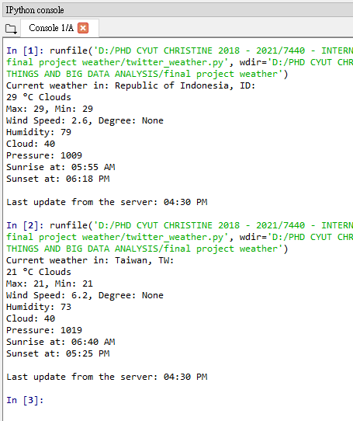
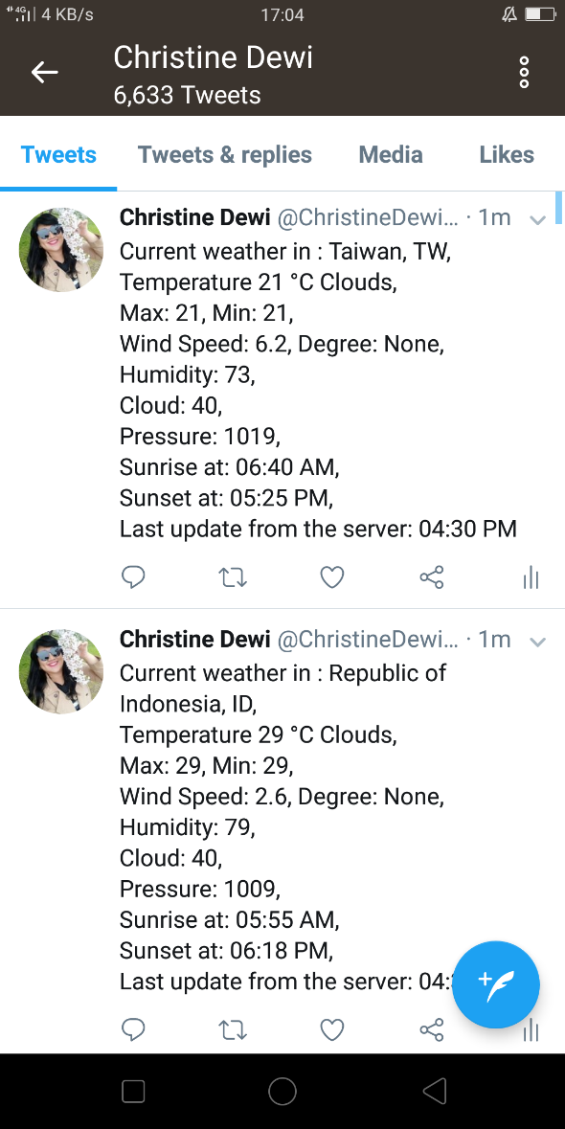

B1. write a program to find the best stock value interest rate during the ten years and return its stroke price at a selected category.
Website
https://finance.yahoo.com/quote/MSFT/history?period1=1199980800&period2=1515600000&interval=1mo&filter=history&frequency=1mo
https://finance.yahoo.com/quote/GOOG/history?p=GOOG
https://finance.yahoo.com/quote/AAPL/history?p=AAPL
https://finance.yahoo.com/quote/MSFT?p=MSFT

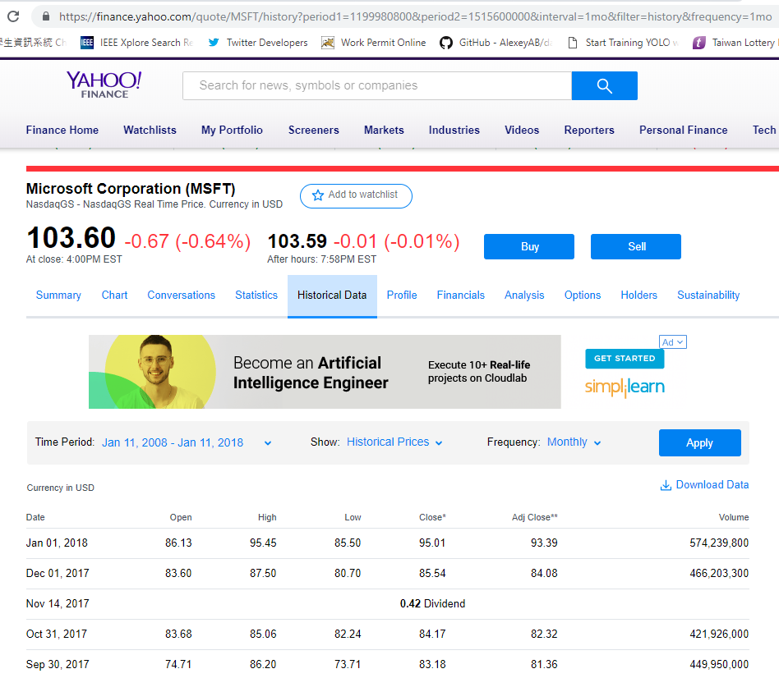
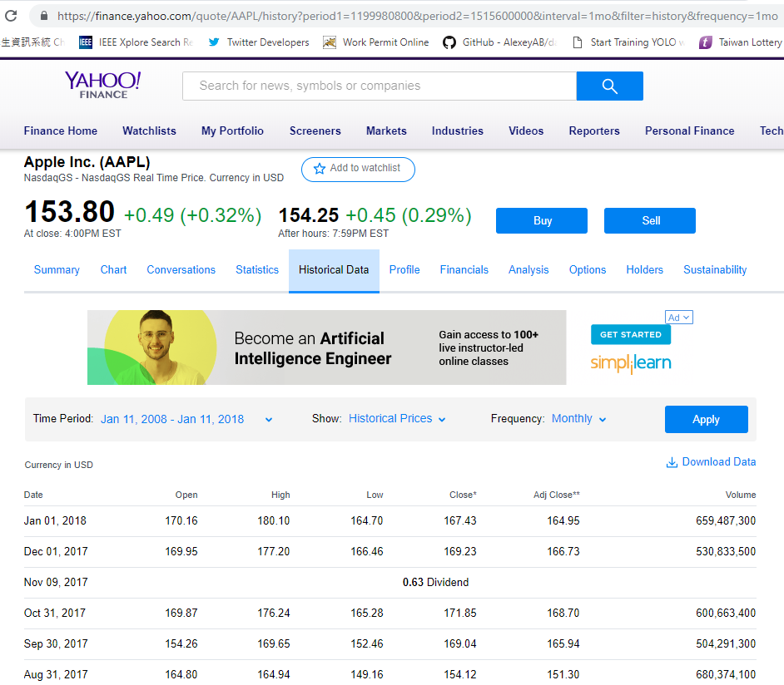
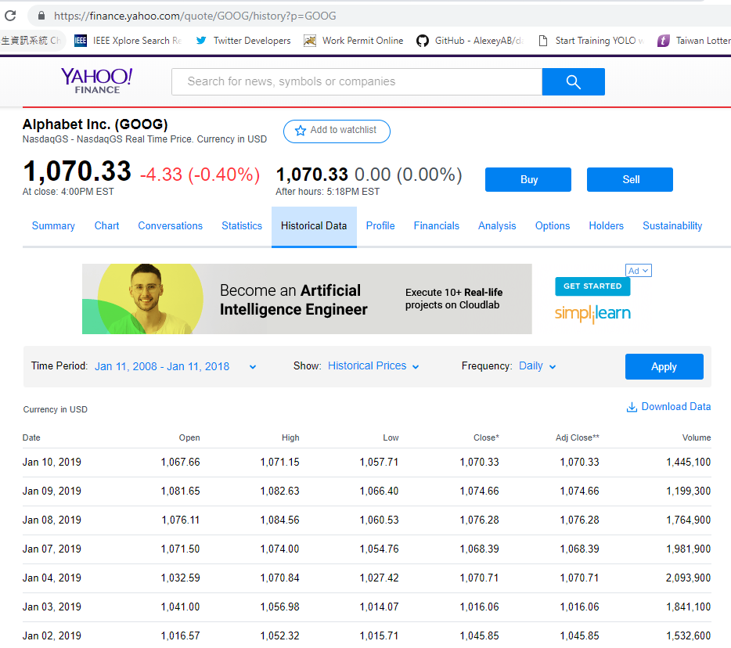
Sourcecode Phyton

from pandas_datareader import data
import datetime as dt
import pandas as pd
ticker = 'GLD'
start = '2008-11-11'
end = '2018-11-11'
#data1 = data.DataReader(ticker,'yahoo',dt.datetime(2014,11,11),dt.datetime(2016,11,11))
#print (data1)
#data1.head()
apple = data.DataReader("AAPL", "yahoo", start, end)
microsoft = data.DataReader("MSFT", "yahoo", start, end)
google = data.DataReader("GOOG", "yahoo", start, end)
stocks1 = pd.DataFrame({"AAPL": apple["High"],
"MSFT": microsoft["High"],
"GOOG": google["High"]})
#print("HIGH")
#print(stocks1)
stocks1.plot(kind='line', title='HIGH', fontsize=9, figsize=(16,9))

stocks = pd.DataFrame({"AAPL": apple["Adj Close"],
"MSFT": microsoft["Adj Close"],
"GOOG": google["Adj Close"]})
#print("Adj Close")
print(stocks)
stocks1 = pd.DataFrame({"AAPL": apple["High"],
"MSFT": microsoft["High"],
"GOOG": google["High"]})
stocks2 = pd.DataFrame({"AAPL": apple["High"]})
stocks2.plot(kind='line', title='HIGH', fontsize=9, figsize=(16,9))
stocks3 = pd.DataFrame({"MSFT": microsoft["High"]})
stocks3.plot(kind='line', title='HIGH', fontsize=9, figsize=(16,9))
stocks4 = pd.DataFrame({"GOOG": google["High"]})
stocks4.plot(kind='line', title='HIGH', fontsize=9, figsize=(16,9))
#print(stocks.head())
import warnings
warnings.simplefilter(action='ignore', category=FutureWarning)
print(stocks.describe())

Output :
AAPL MSFT GOOG
Date
2008-11-10 9.172466 16.511391 158.360016
2008-11-11 9.066278 16.433884 154.723679
2008-11-12 8.621430 15.736219 144.559784
2008-11-13 9.226040 16.472643 155.031662
2008-11-14 8.632909 15.550173 154.008331
2008-11-17 8.432014 14.976538 149.090317
2008-11-18 8.601339 15.312129 147.749039
2008-11-19 8.255028 14.274149 139.184738
2008-11-20 7.700166 13.681017 128.941360
2008-11-21 7.900108 15.358953 130.367081
2008-11-24 8.892167 16.147192 127.888214
2008-11-25 8.686484 15.600885 140.113693
2008-11-26 9.088281 15.991108 145.101257
2008-11-28 8.865379 15.780389 145.533447
2008-12-01 8.507588 14.523888 132.135590
2008-12-02 8.846247 14.945321 136.666122
2008-12-03 9.174378 15.507243 138.812164
2008-12-04 8.744838 14.914101 136.283600
2008-12-05 8.992613 15.507243 141.077423
2008-12-08 9.539826 16.396933 150.078888
2008-12-09 9.572351 16.076958 151.996414
2008-12-10 9.395370 16.084755 153.412201
2008-12-11 9.088281 15.179452 149.139984
2008-12-12 9.401108 15.109216 156.859772
2008-12-15 9.064364 14.859482 154.331223
2008-12-16 9.129417 15.694537 161.589020
2008-12-17 8.529592 15.343344 156.601456
2008-12-18 8.555419 15.062388 154.137482
2008-12-19 8.609949 14.921913 154.082840
2008-12-22 8.202415 14.968731 147.595032
... ... ...
2018-10-01 226.469803 115.112709 1195.310059
2018-10-02 228.482788 114.654686 1200.109985
2018-10-03 231.263092 114.674599 1202.949951
2018-10-04 227.197281 112.304832 1168.189941
2018-10-05 223.510132 111.647675 1157.349976
2018-10-08 222.991943 110.373177 1148.969971
2018-10-09 226.081161 111.777115 1138.819946
2018-10-10 215.607712 105.703354 1081.219971
2018-10-11 213.704346 105.454430 1079.319946
2018-10-12 221.337723 109.098686 1110.079956
2018-10-15 216.604233 107.137161 1092.250000
2018-10-16 221.377563 110.522537 1121.280029
2018-10-17 220.420914 110.233780 1115.689941
2018-10-18 215.268890 108.033287 1087.969971
2018-10-19 218.547455 108.192604 1096.459961
2018-10-22 219.882782 109.158424 1101.160034
2018-10-23 221.955551 107.635010 1103.689941
2018-10-24 214.342117 101.879875 1050.709961
2018-10-25 219.035751 107.834152 1095.569946
2018-10-26 215.547913 106.499908 1071.469971
2018-10-29 211.502045 103.403290 1020.080017
2018-10-30 212.558350 103.283813 1036.209961
2018-10-31 218.099014 106.350555 1076.770020
2018-11-01 221.447327 105.464386 1070.000000
2018-11-02 206.758575 105.703354 1057.790039
2018-11-05 200.889053 107.047546 1040.089966
2018-11-06 203.061493 107.256645 1055.810059
2018-11-07 209.219986 111.478401 1093.390015
2018-11-08 208.490005 111.269310 1082.400024
2018-11-09 204.470001 109.098686 1066.150024

[2519 rows x 3 columns]

AAPL MSFT GOOG
count 2519.000000 2519.000000 2519.000000
mean 79.289931 40.704976 533.997504
std 53.885561 24.292254 289.018709
min 7.481090 11.904654 127.888214
25% 33.264540 22.694489 289.308334
50% 65.604202 31.763430 504.125763
75% 112.118454 51.029520 739.885010
max 231.263092 115.112709 1268.329956
